**Check on CMDB Defects (New install and Decom of servers)**

1. To verify the CMDB CI records for VMs, export the CMDB records to an excel. Use below link to open the CI records in Atos Global SNOW

<https://atosglobal.service-now.com/nav_to.do?uri=%2Fcmdb_ci_list.do%3Fsysparm_clear_stack%3Dtrue>

1. Add a filter for each customer to export records specific to each customer. Make sure to add field “Operational status” Export to check the status of record. Export the data into an excel.

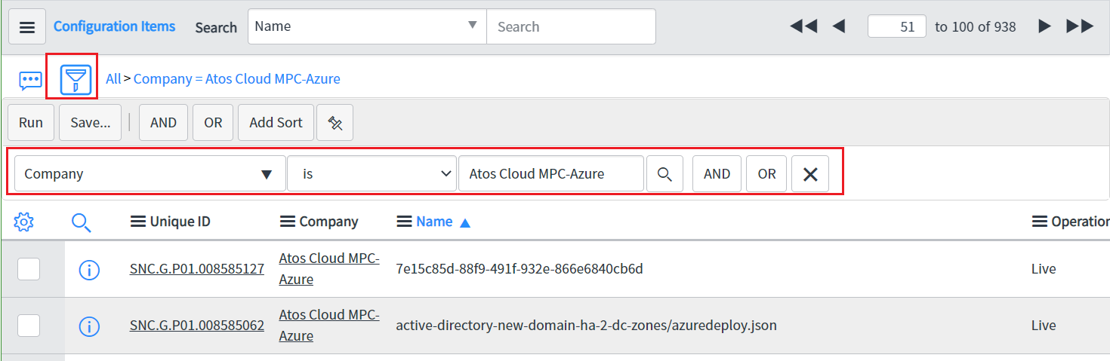

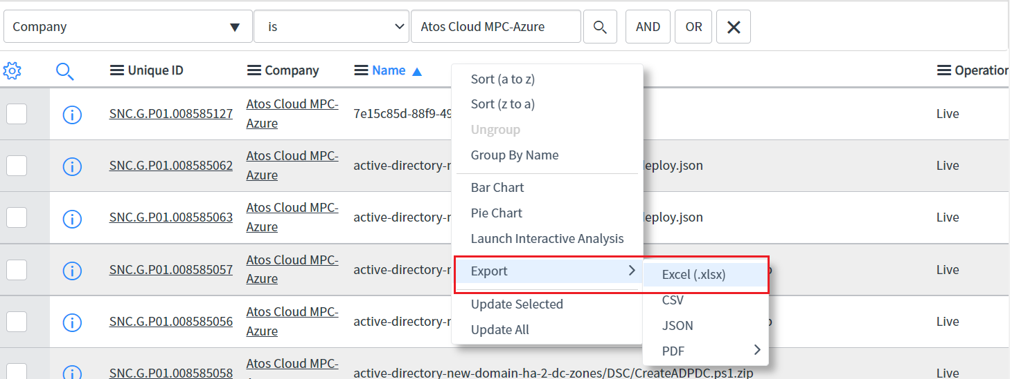

1. Goto Azure portal and get the list of VM. Export the list

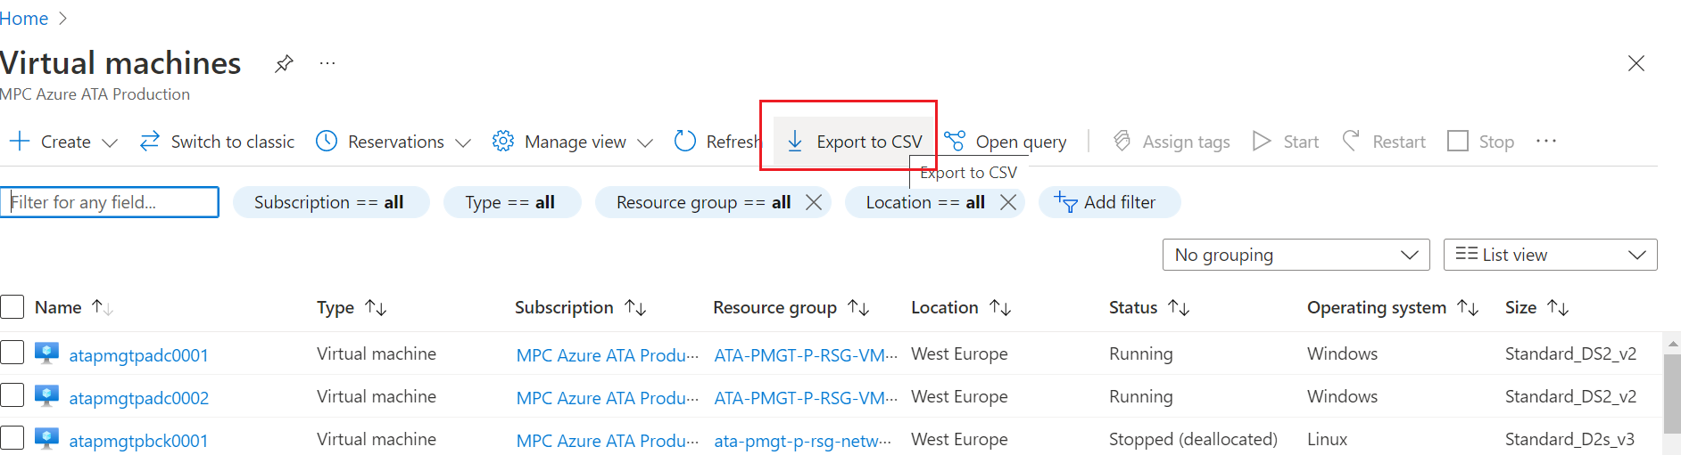

1. Make sure that all VM from portal list is available in CMDB and in proper operational status. If there is any update is required, contact respective client configuration manager \ SDM to get it updated.